Artificial Intelligence & Machine Learning
Project Documentation format
1. Introduction
• Project Title: HematoVision – Advanced Blood Cell Classification Using Transfer Learning
• Team Members:
BAITAPALLI KISHOR-Model Development, Flask Integration, Performance Testing, Deployment
Kenguva Pavan-Dataset Collection, Data Preprocessing, UI Design, Testing & Documentation Support
2. Project Overview
• Purpose: The purpose of HematoVision is to automate blood cell classification using deep learning. The system reduces manual effort in microscopic blood analysis and improves diagnostic efficiency.
•Features:
- Image upload functionality
- Automated blood cell classification
- Prediction confidence display
- Invalid image detection
- Web-based interface using Flask
- MobileNetV2 Transfer Learning Model

3. Architecture
Frontend:
- HTML
- CSS
- Bootstrap
- Jinja2 Templates
Backend:
- Python
- Flask Framework
- REST-based routing
- Model integration using TensorFlow/Keras
Database:
- No external database used
- Image dataset stored in local directory
- Model stored as .h5 file
4. Setup Instructions
Prerequisites:
- Python 3.10+
- TensorFlow
- Flask
- scikit-learn
- matplotlib
Installation:
- git clone https://github.com/Baitapallikishor/HematoVision.git
- cd HematoVision
- pip install -r requirements.txt
- python train_model.py
- python app.py
5. Folder Structure
The HematoVision project follows a Python Flask-based architecture. The folder structure is organized as follows:
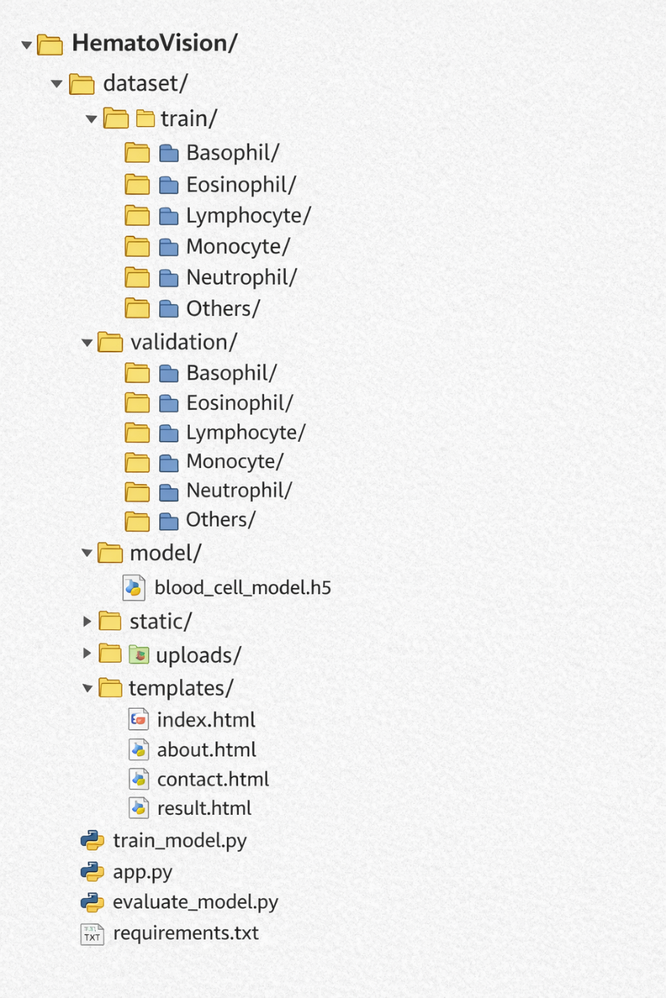

Description:
- dataset/ – Contains training and validation image data.
- model/ – Stores the trained deep learning model file (.h5).
- static/ – Stores uploaded images and static assets.
- templates/ – Contains HTML pages for the web interface.
- train_model.py – Script used for training the MobileNetV2 model.
- app.py – Flask backend application for prediction and routing.
- requirements.txt – Lists required Python dependencies.

6. Running the Application
Step 1: Train the Model
python train_model.py
Step 2: Run the Flask Application
python app.py
Step 3: Open in Browser
http://127.0.0.1:5000
7. API Documentation
POST /predict
Description:
Accepts image file and returns prediction result.
Request:
Form-data image upload
Response:
Predicted class and confidence percentage.

8. Authentication
• No authentication system implemented.
• Application is publicly accessible for testing.

9. User Interface

Include screenshots of:
- Home Page
- Upload Section
- Prediction Result Page
- Confusion Matrix
10. Testing
- Functional Testing
- Performance Testing
- Confusion Matrix Analysis
- Classification Report
11. Screenshots or Demo
Include:
- Accuracy Graph
- Confusion Matrix
- Classification Report
- Flask Prediction Output
12. Known Issues
- Minor misclassification between Monocyte and Eosinophil
- Performance depends on system hardware
13. Future Enhancements
- Add database for storing prediction history
- Improve accuracy using more dataset
- Deploy on cloud server
- Add user authentication
- Add support for additional blood disorders

